Lab Exercise 4
IBM Bluemix DevOps Services (Web)
(Version 2.2)

Author(s):

Mangalaganesh Balasubramanian, GBS BPM & I , Australia
Kaustubh Roy Chowdhury, GBS India
Shri Santhana, GBS Singapore
Manendra Rawat, GBS India
Shahir A. Daya, GBS Cloud CoC
William A Brown, GBS Cloud CoC
Table of Contents

1 Pre-requisites to participate in this lab 3
2 Learning objectives 3
3 IBM Bluemix DevOps Services (Web) 3
3.1 Create Java Web Starter application on Bluemix 3
3.2 Exploring the Bluemix DevOps Services and Configuring the Build & Deploy 14
3.3 Viewing the Build and Deploy logs 24
References 26

Pre-requisites to participate in this lab
What do you need to participate in this lab? You need an IBM Bluemix account
(https://ng.bluemix.net) and a modern browser like Chrome, Firefox, IE10+ or Safari.

Learning objectives
This lab introduces you to IBM Bluemix DevOps Services (IDS). This was formally called JazzHub. It focuses on how to use it with Bluemix.
When the lab is completed, your application code will reside in IDS and you will have automated the Build and Deploy process from IDS to Bluemix.

IBM Bluemix DevOps Services (Web)
In this lab, you will create a Java app and make simple changes to the code to understand how the DevOps services work. DevOps services are available only in the production Bluemix and not on the staging Bluemix.

Create Java Web Starter application on Bluemix
- Login to Bluemix (https://ace.ng.bluemix.net) and navigate to your dashboard.
- Click on the "CREATE APP" button.
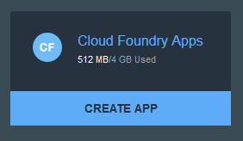
- Choose WEB as the kind of app you are creating.
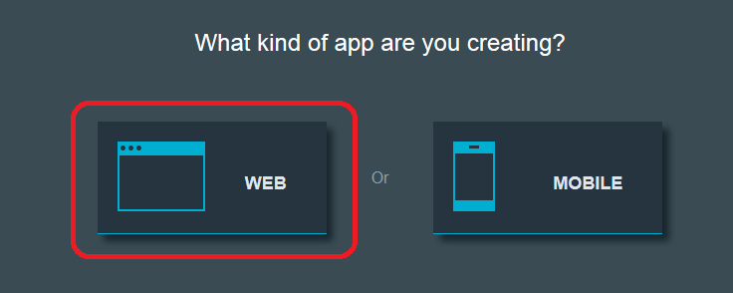
- Choose “Browse Boilerplates”
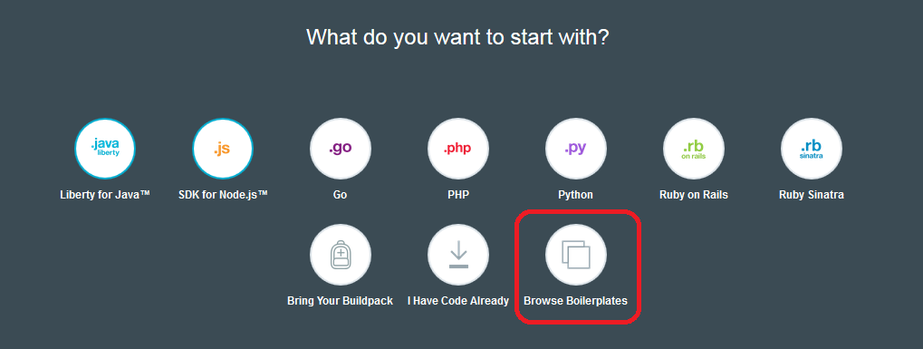
- Click the BROWSE BOILERPLATES button.
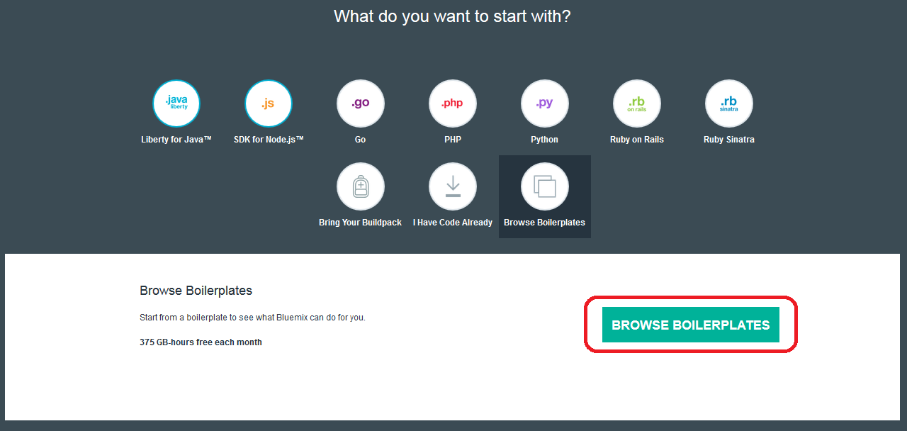
- Choose the "Java Web Starter" Boiler Plate
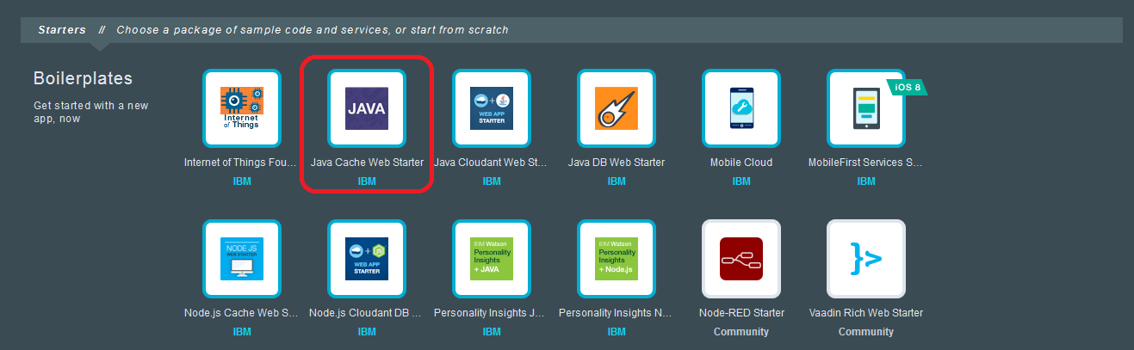
- The Java Cache Web Starter boiler plate uses the WebSphere Liberty run-time. The application created uses the Data Cache service
- Choose an appropriate name and host for this application
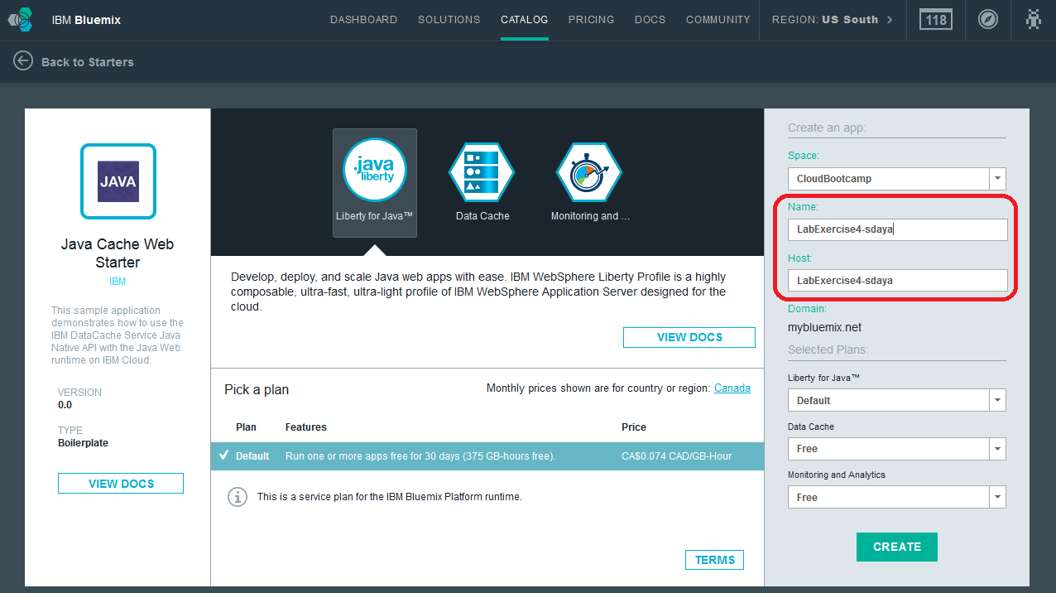
- Click on the CREATE button to complete the application creation process.
- You will see the following screen with options you have to start coding along with step-by-step instructions.
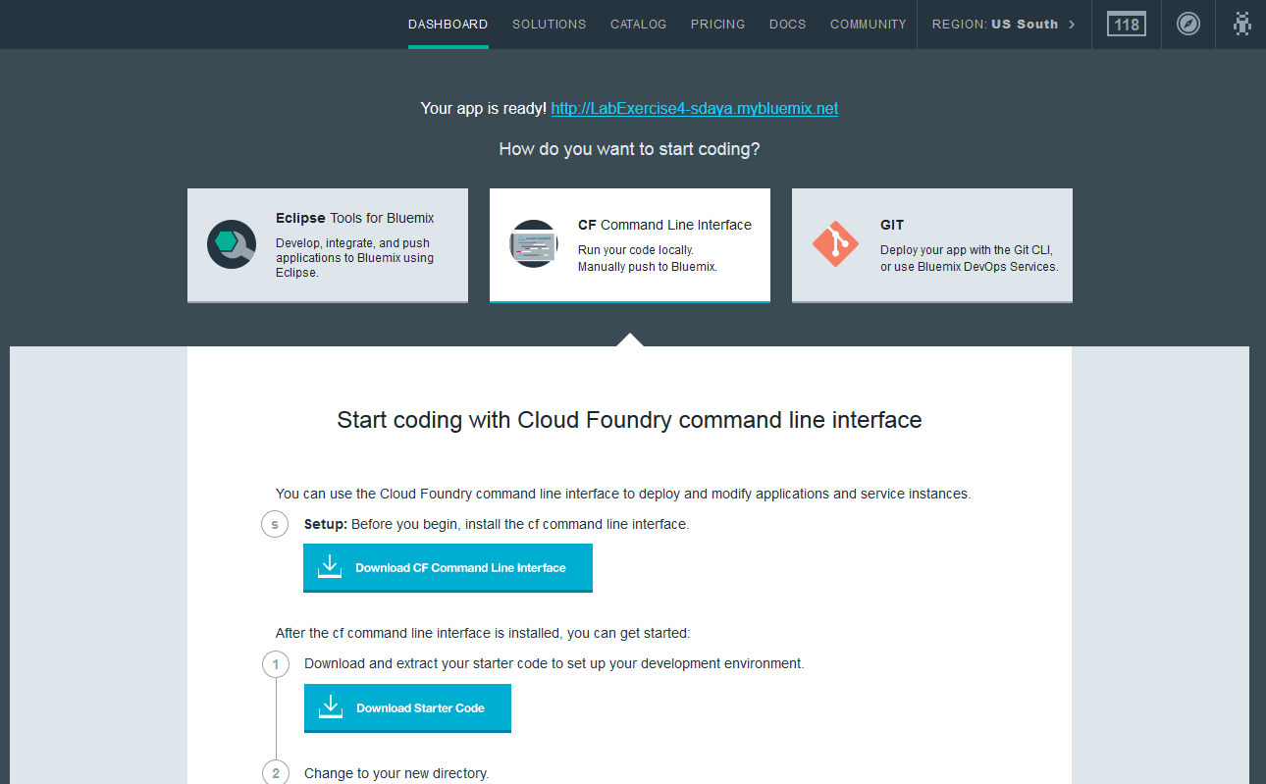
- At the bottom of the instructions, you will see a VIEW APP OVERVIEW BUTTON.
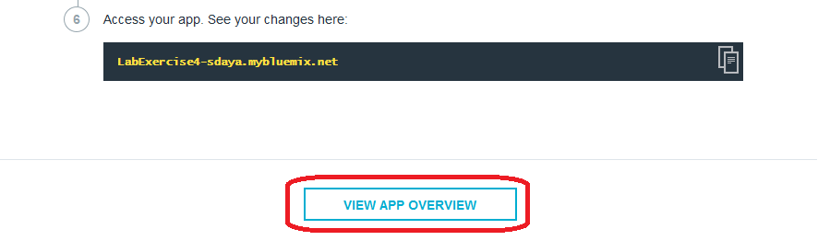
- When you click the VIEW APP OVERVIEW button you will be taken to the app overview screen.
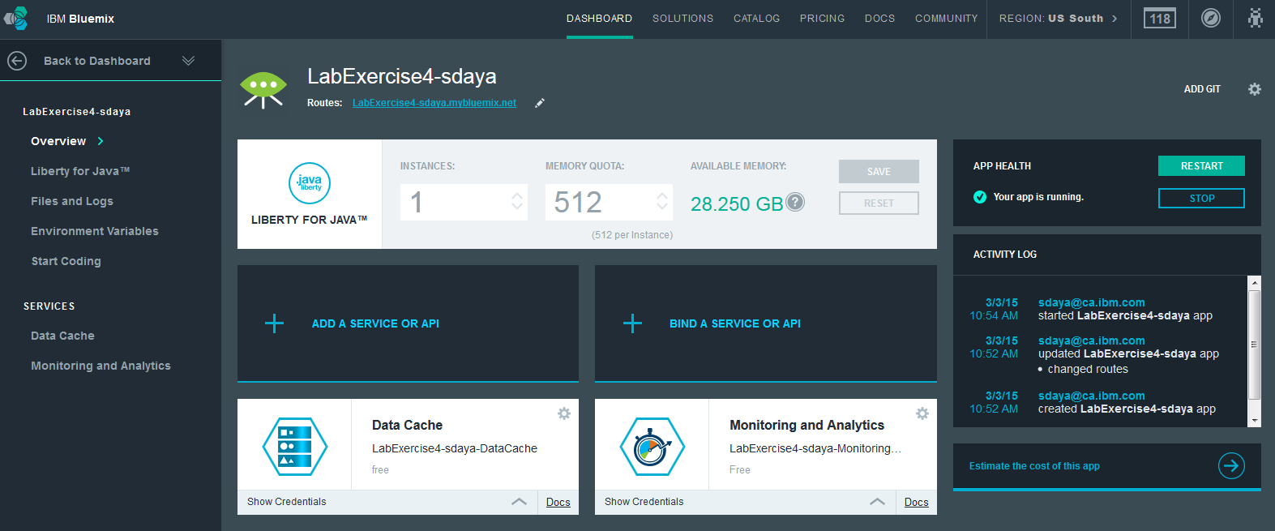
- If you click on the “DASHBOARD”, the application can be seen on the dashboard. The application should be started.
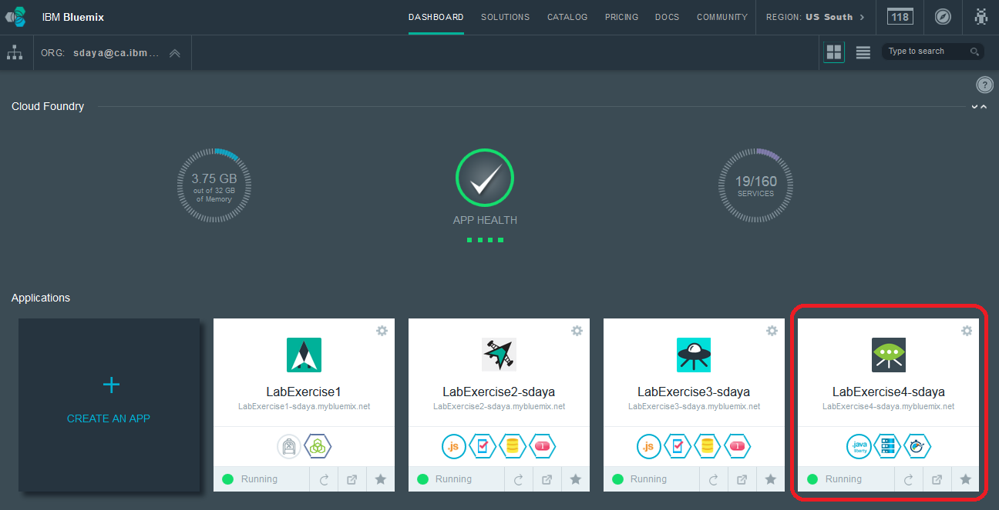
Note: In the application view on the DASHBOARD, Click on the application to return to the Overview page
- The overview page includes a link to the Routes for the application. If you click on the Routes a browser page will open and display your application in it current state.
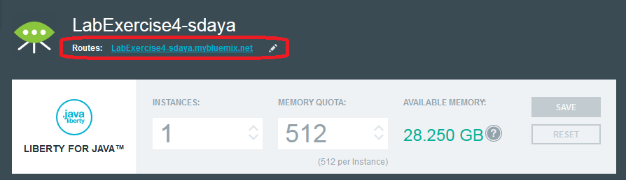

Note: Browser view of as is Application
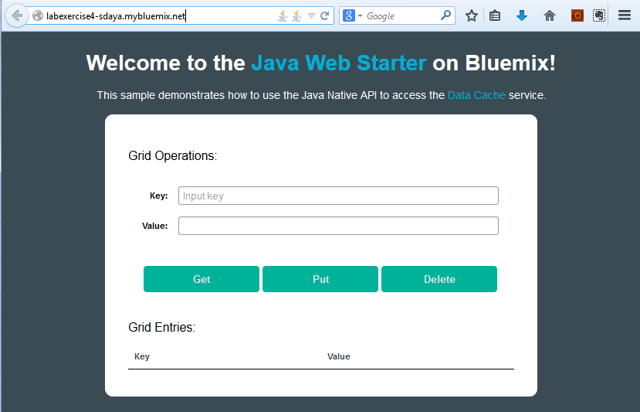
- Click on ADD GIT
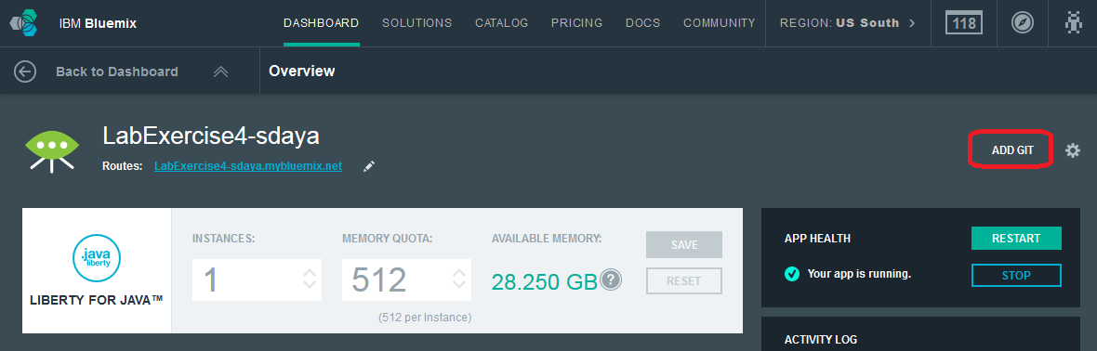
- The following pop-up will result.
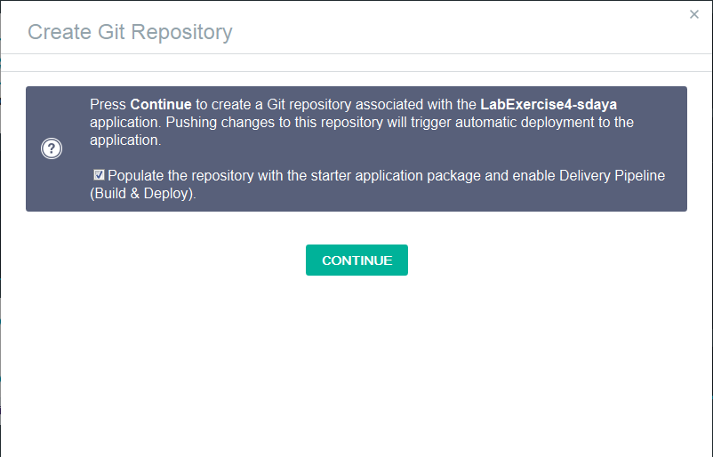
- Click on the CONTINUE button to create a Git repository associated with your application. Ensure that you check the “Populate the repository with the starter application package and deploy it to the application.” checkbox.
- The Git repository is successfully created and ready to use. Click Close to proceed further.
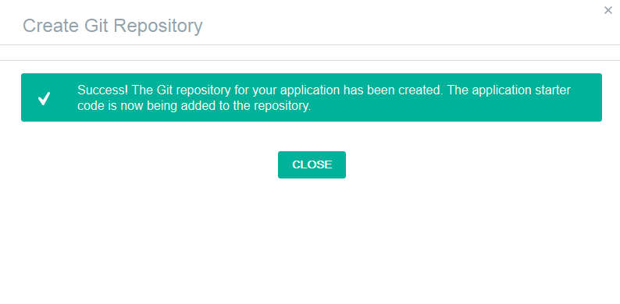
- You will receive an email from the IBM DevOps Services email similar to the following detailing your project specifics and providing some useful links with tutorials on how to use your new Git repository.
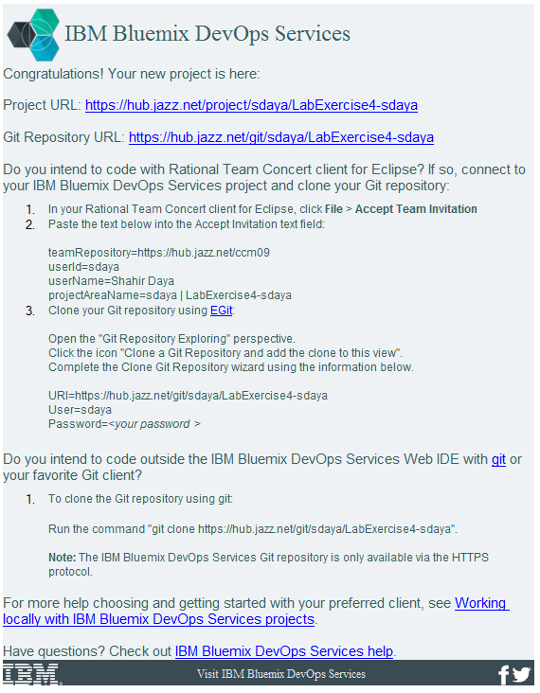
- The overview page now shows the GIT URL and a link to access the project artefacts (using the Code link)
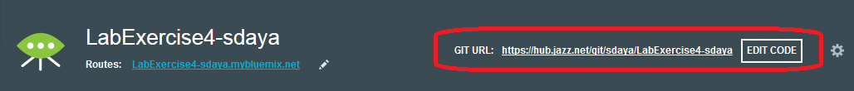
- Click on the EDIT CODE link. A new browser window will open where you will see the project artefacts. This new browser window is the DevOps Services user interface that provides your Git Services.
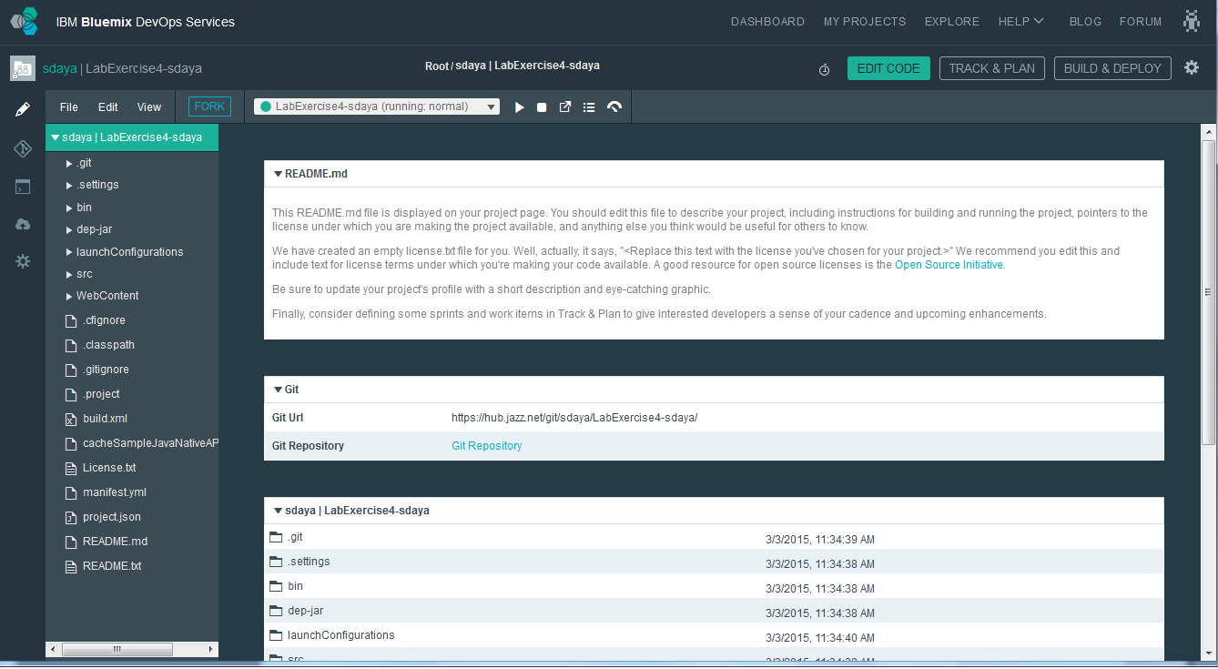
- Explore the contents of this page.

Exploring the Bluemix DevOps Services and Configuring the Build & Deploy
In this section you will explore the “EDIT CODE”, “TRACK & PLAN” and “BUILD & DEPLOY” functions.
To start you will make a simple change using the web editor. You will build and deploy the changes and observe them by running you application.
- The top right of the DevOps page shows a few key controls that we would use in this exercise. You would edit code and perform a Build and Deploy.
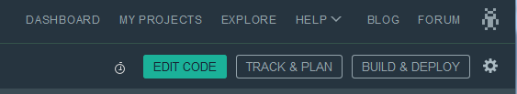
- Click on EDIT CODE
- Expand WebContent in the navigation bar and locate index.html
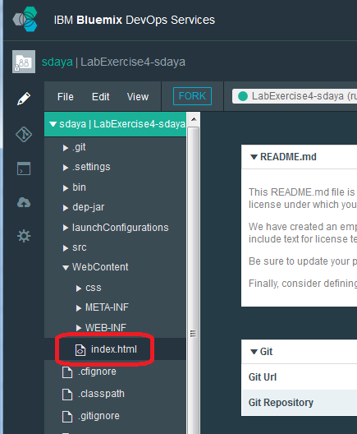
- Make minor changes to the index.html file to explore the build and deploy functionality. Locate the body onload line and change the header to read differently. As an example add a "test" phrase as suffix. Also change the web forms label names: The changes are shown in bold text below.

<body onload="load();">
<h1>
Welcome to the <span class="blue">Java Web Starter</span> on Bluemix! Test!!!
</h1>
<br />
<div class = "description">This sample demonstrates how to use the Java Native API to access the <span class = "blue">Data Cache</span> service. </div>
<br />
<div class="container" style="color: black">
<h2>Grid Operations:</h2>
<br />
<form class="form-horizontal" style="width: 800px">
<div class="form-group">
<label for="key">First and Last Name:</label>
<input id="key" class="form-control" type='text' name='key' placeholder="Input key" />
</div>
<div class="form-group">
<label for="value">Value: </label>
<input id='value' class="form-control" type="text" name='value' />
</div>
</form>
The changes are saved automatically. The default setting is configured to have auto-save turned on. This can be changed by altering the settings if you desire. The spinner (gear icon) on the left side tool bar allows you to make the changes.
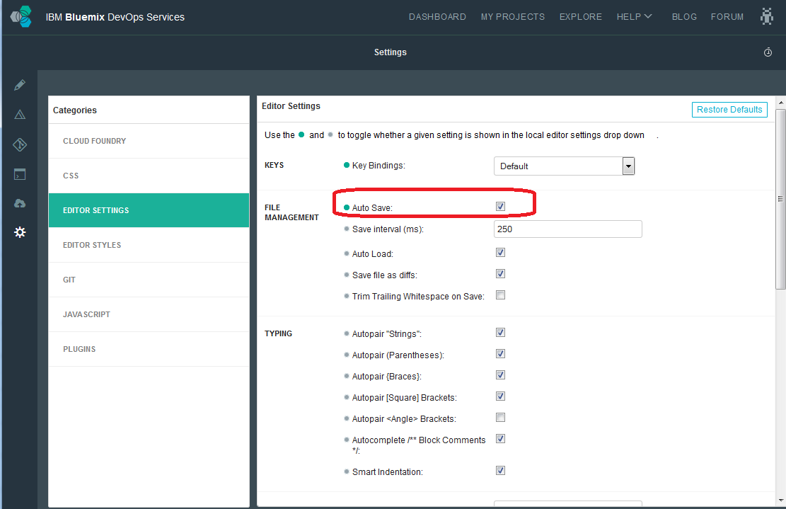
Click the browser Back button to get back to the “Editor”
- Click on BUILD & DEPLOY. You will see a screen similar to the following.
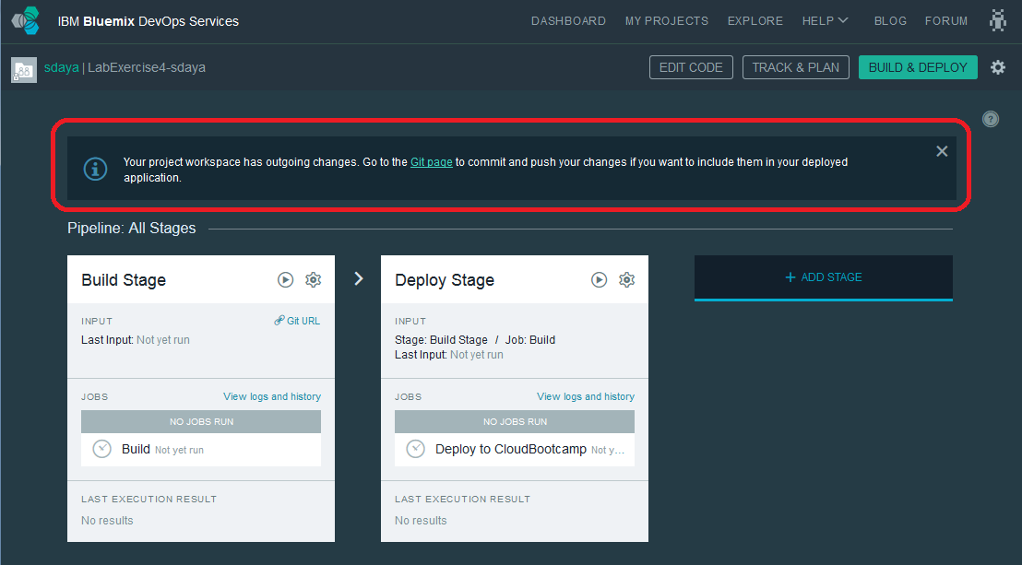
- IBM Bluemix DevOps Services has identified that there is an outgoing change.
- Click on the “Git page” link to identify the outgoing changes and commit them. The build process would use the checked in artefacts.
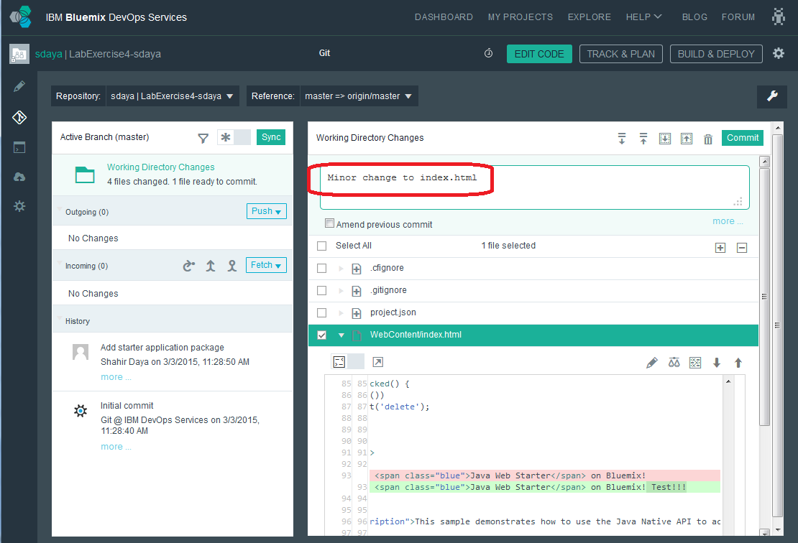
- Check the WebContent/index.html. Specify a commit message and click on COMMIT. The changes are committed.
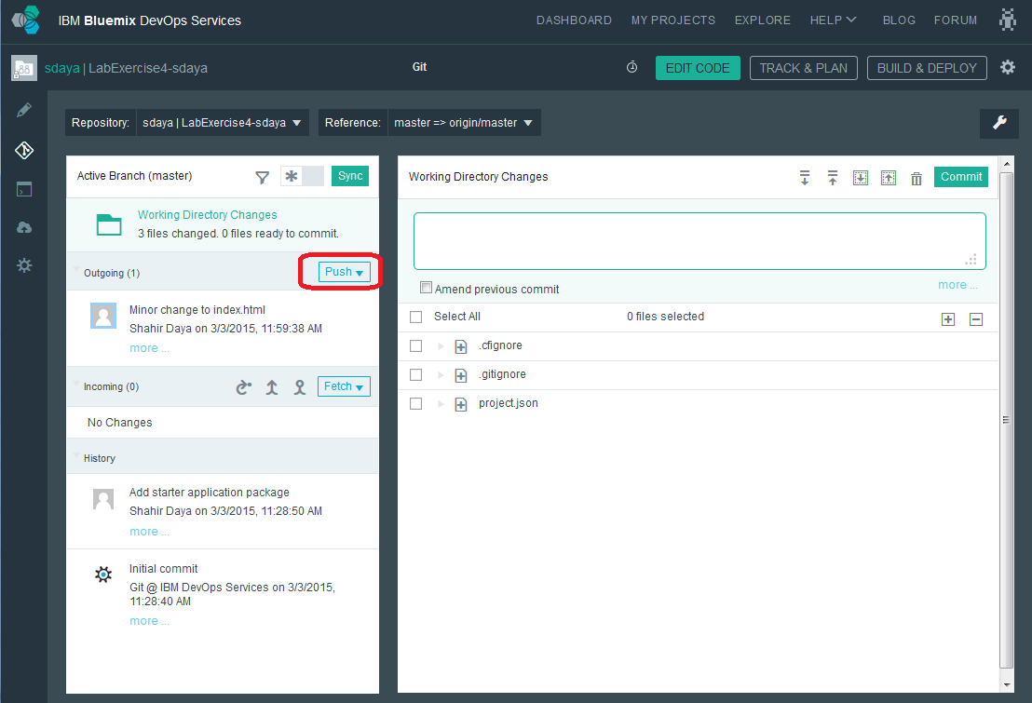
- Push the changes to the remote origin master by clicking on the PUSH button.
- Now the local and remote Git Repositories are in Synch as seen by No Incoming and Outgoing commits
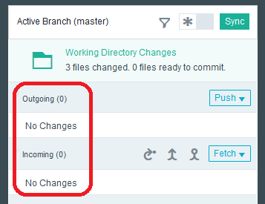
- Click on BUILD & DEPLOY
- You will see the following screen showing a pipeline with a Build stage and a Deploy stage. The Builder and Deployer will already be configured and you’ll see that a build and deploy was automatically done and our “Minor change to index.html” was deployed. The build stage is configured such that a build occurs automatically once code is committed. Also, the deploy stage is configured to run on successful completion of the previous stage.
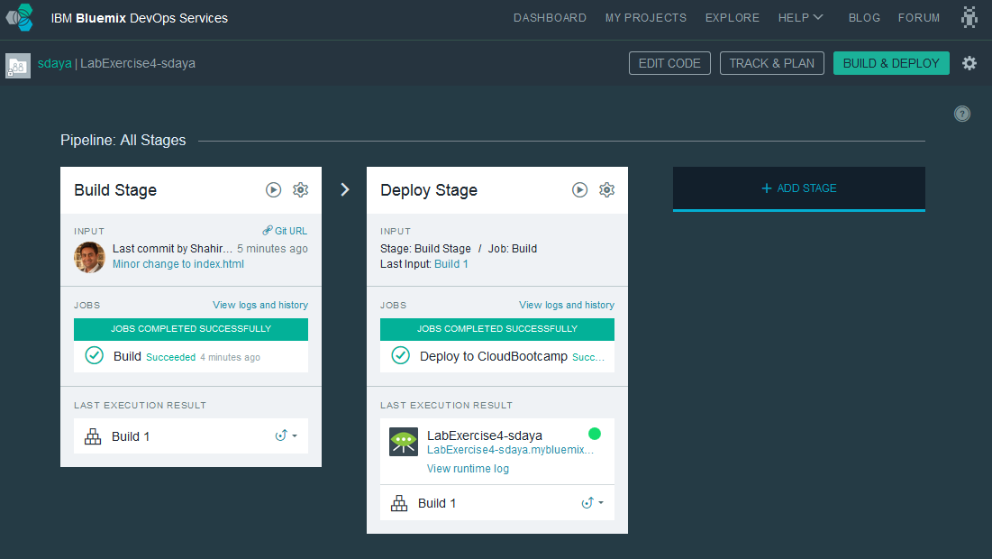
- Click on the gear icon in the upper right hand corner of the Builder and select Configure Stage. Examine the configuration options that are available.
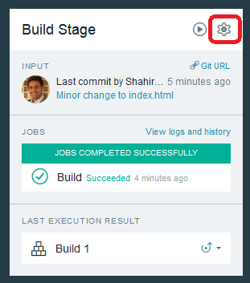
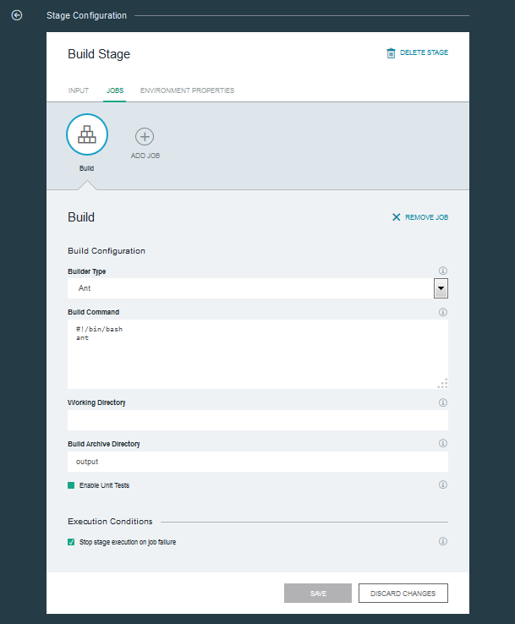
- Click on the gear icon in the upper right hand corner of the Deployer to explore the Deploy stage configuration.
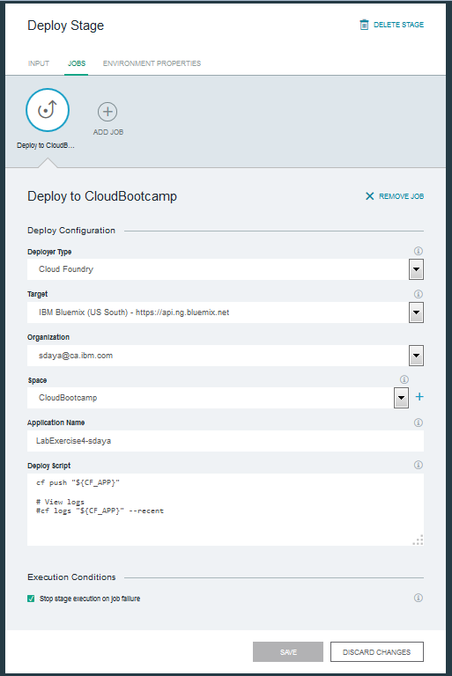
- Click on the Run Stage icon
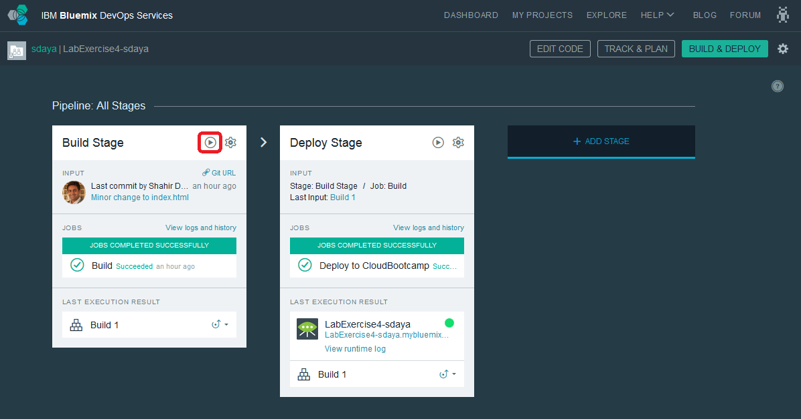
- A Build is started and it is automatically followed by a Deploy. Build and Deploy are two discrete activities (stages in the pipeline) and each of them has their own status. Observe below that the build is successful and has been successfully deployed. The illustration below shows the progression from build to deploy.
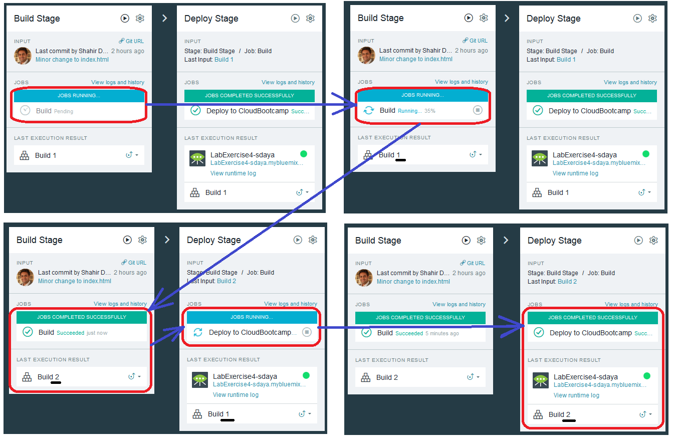
- Click on the application URL link to confirm that the changes you made to the index.html were successfully deployed.
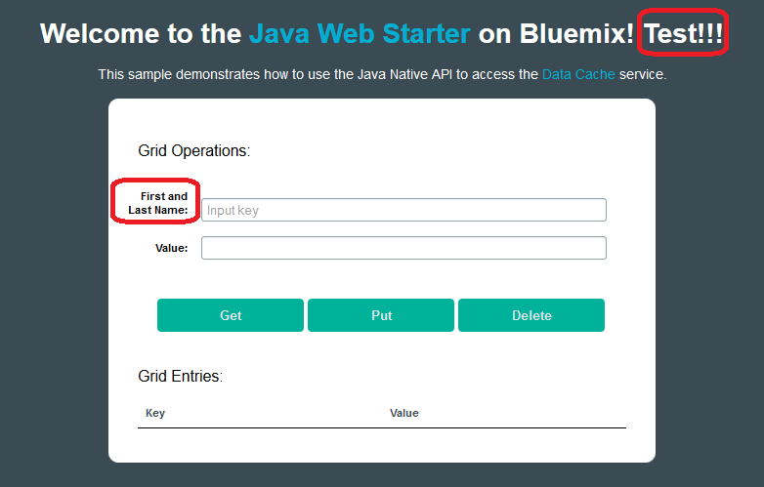

Viewing the Build and Deploy logs
In this section, you will view the build and deploy logs.
- The Deployment logs can be seen by clicking the Build Succeeded or Failed message (depending on the outcome of the Deploy step). In our case the Deploy was successful.
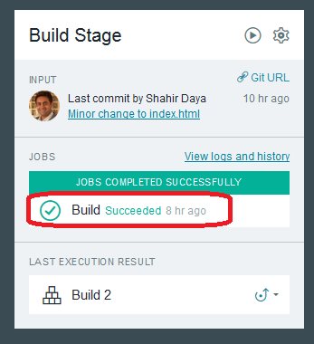
A screen similar to the following will be displayed.
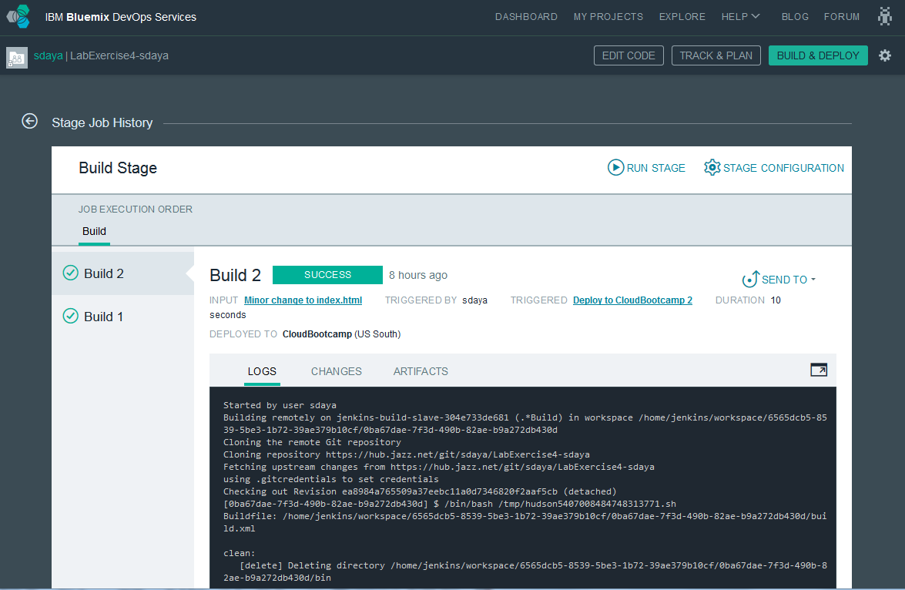
- Now let's view the history of our Build step. This can be viewed by clicking on Build 1 link. It is available in two places as marked in the figure below.
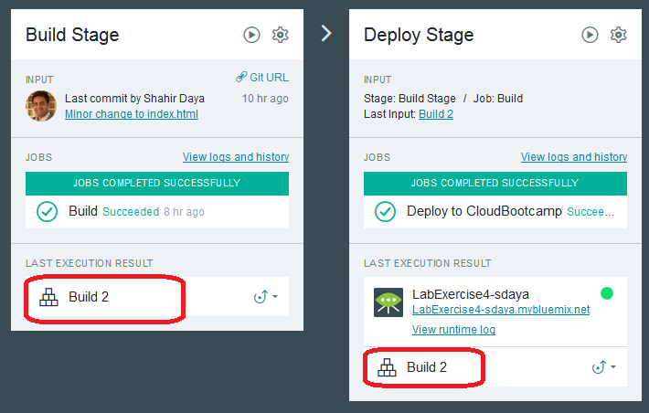
- Examine our Build Logs
- The builder uses "Jenkins" under the covers to perform the application build. Explore the other tabs; CHANGES and ARTIFACTS .
In this exercise you created a java cache web starter app on Bluemix. You moved the artefacts to a Git repository provided by IBM DevOps Services. You made a change to a project artefact. The changes were built and deployed to Bluemix.

References
- Hub.jazz.net, (2014). Learn - IBM DevOps Services. [online] Available at: https://hub.jazz.net/learn [Accessed 4 Sep. 2014].

END OF DOCUMENT

